Cables for drive technology found, ordered and connectorised quickly at igus
New "Drive" website and online tools help to select the best cable for use in energy chains

In the desired length, from 1 metre, without minimum order quantity with or without connector. The motion plastics specialist igus always offers users the best and most cost-effective solution from a single source. Practical online tools help the customer, for example, to choose the appropriate ready-to-connect drive cable, or determine the precise service life of the selected cable after entering the application parameters. A new website published by igus for the SPS IPC Drives now provides information on current trends in drive technology and provides a comprehensive overview of the diverse cable selection.

If the user is looking for a drive cable, then igus, with its portfolio of more than 1,350 cables, always has the optimum solution for the respective application at the most cost-effective price. The motion cable specialist has been developing cables specifically for use in the energy chain for over 30 years and testing them in the largest laboratory for moving applications in the industry. With over two billion test cycles and more than 1.4 million electrical tests per year, igus is the number one for moving cables in energy chains. The new website www.igus.eu/drive now provides a new gateway to the diverse world of igus cables. From cables sold by the metre and the harnessed, ready-to-connect drive cable with connector up to the special cable in the desired length. The customer has a wide choice. The "Drive" website offers the user a comprehensive overview of the drive technology, the igus test laboratory and the in-house harnessing of cables. In addition, the user has the option to order free samples or directly order the appropriate cable that he wants from the shop.

Tested ready-to-connect cables for motion
All chainflex cable designs have been qualified in a series of extensive tests before the market launch. For example, the TPE servo cable CF29.25.15.02.01.D in Test 5034 withstood 45 million strokes with a bend radius of 7.2 x d. All cables are subjected to a rigorous quality testing programme that even includes batch testing. The jacket materials specifically developed for use in the energy chain offer a wide selection: from PVC and highly oil-resistant PUR up to TPE, the best and most durable material for continuous movement in the energy chain. In addition, the many approvals of cables such as UL, EAC or DNV-GL have the great advantage that the users do not have to obtain their own certificates for the components used and is always safe when exporting machines.

readycable finder helps with quick selection
Upon request igus offers all cables from one source, as a so-called "readycable", tested and with connector. The online tool "readycable finder" helps to select the right drive cable from over 4,200 types according to 24 manufacturer standards, which can then be ordered directly from stock via the online shop. Since all cables are tested in our own test laboratory spread over 2,750 square metres of floor space, igus is the only manufacturer on the market to offer a unique 36-month guarantee on its complete line of cables. The data from the test laboratory is also included in the service life calculator; this gives reliable statements about the durability in the respective application.

Caption:

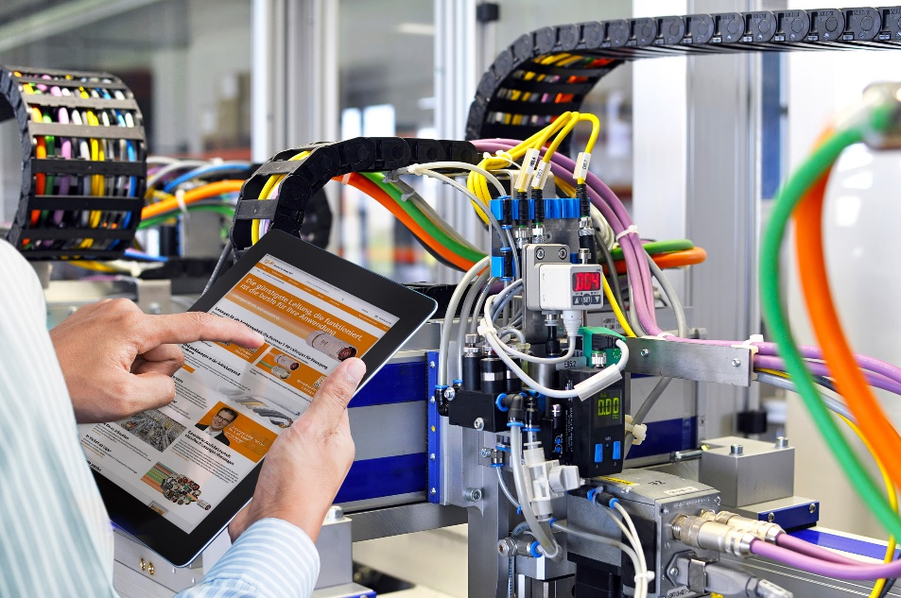
Picture PM7318-1
With the new website www.igus.eu/drive, igus helps the user to find technically the best and most cost-effective drive cable for use in the energy chain. (Source: igus GmbH)

PRESS CONTACT:  Lena Tan  Operations Director  Asean Region  igus® Singapore Pte Ltd.  84 Genting Lane  #06-03 Axxel Innovation Centre  Singapore 349584  Phone: +65-64 87 14 11  Fax: +65-64 87 15 11  letan@igus.com.sg  www.igus.com.sg | ABOUT IGUS:  igus GmbH is a globally leading manufacturer of energy chain systems and polymer plain bearings. The Cologne-based family business has offices in 35 countries and employs 3.800 people around the world. In 2017, igus generated a turnover of 690 million euros with motion plastics, plastic components for moving applications. igus operates the largest test laboratories and factories in its sector to offer customers quick turnaround times on innovative products and solutions tailored to their needs.

The terms "igus", “Apiro”, "chainflex", "CFRIP", "conprotect", "CTD", "drylin", "dry-tech", "dryspin", "easy chain", "e-chain", "e-chain systems", "e-ketten", "e-kettensysteme", "e-skin", "flizz", “ibow”, “igear”, "iglide", "iglidur", "igubal", “kineKIT”, "manus", "motion plastics", "pikchain", "plastics for longer life", "readychain", "readycable", “ReBeL”, "speedigus", "triflex", "robolink", and "xiros" are protected by trademark laws in the Federal Republic of Germany and internationally, where applicable.

