Video: Heavy bridge raised easily with secure energy supply from igus
Pre-assembled e-chain system ensures a fail-safe energy supply at the Memorial Bridge in New Hampshire

The Memorial Bridge spans the Piscataqua River between Portsmouth, New Hampshire and Kittery, Maine on the east coast of the US. It replaced the original one, which was built in 1923 to remember local sailors and soldiers who participated in the first World War. Pre-assembled energy chains from igus reliably ensure secure energy supply in the lifting bridge.

For ships to pass under the Memorial Bridge, it must be raised by a vertical lifting mechanism. In operation an average speed of 1 m/s is required for a total distance of 40 metres. To reduce maintenance and increase overall reliability, the bridge builders used pre-assembled igus readychains instead of the hanging cables of the original design. The cables, which were harnessed with connectors and fitted in energy chains, were pre-assembled in the nearby igus factory and delivered as ready-to-install systems to be fitted on site.

The igus engineers used highly flexible chainflex cables in the E4 energy chain as well as heavy-duty CFXL clamps for secure cable strain relief. Each of the installed cable types - including the CF300, CF9 and CF34 motor cables and the 4-core CFLG fibre optic cable - were extensively tested in the 2,750 square metre test laboratory. In this way, igus is the only cable manufacturer in the world capable of providing a 36-month guarantee on its chainflex cables.

The readychain systems in operation can be viewed in the video: https://youtu.be/Yt1k0wrgD28

Image captions:

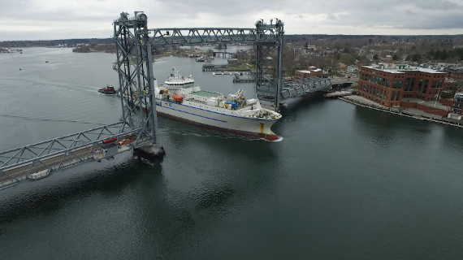
Picture PM3118-1
Today's Memorial Bridge runs along the east coast of the US across the Piscataqua River. It replaced the original bridge of 1923. (Source: igus GmbH)

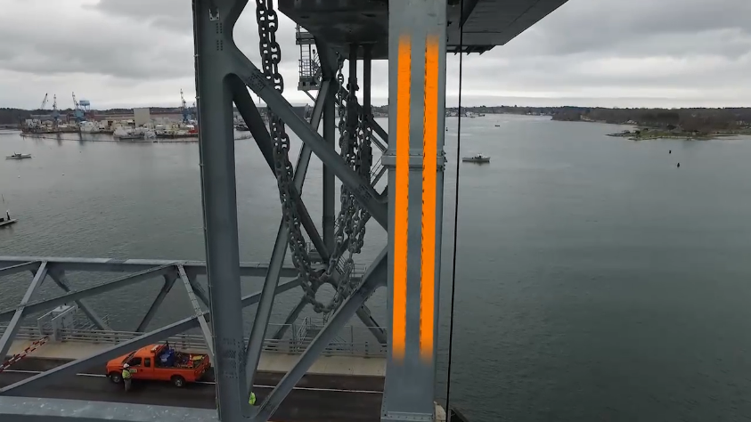
Picture PM3118-2
The lifting bridge uses pre-assembled igus readychain systems instead of the original hanging cables. They offer a much higher level of safety combined with reduced maintenance. (Source: igus GmbH)

PRESS CONTACT:  Lena Tan  Operations Director  Asean Region  igus® Singapore Pte Ltd.  84 Genting Lane  #06-03 Cityneon Design Centre  Singapore 349584  Phone: +65-64 87 14 11  Fax: +65-64 87 15 11  letan@igus.com.sg  www.igus.com.sg | ABOUT IGUS:  igus GmbH is a globally leading manufacturer of energy chain systems and polymer plain bearings. The Cologne-based family business has offices in 35 countries and employs 3.800 people around the world. In 2017, igus generated a turnover of 690 million euros with motion plastics, plastic components for moving applications. igus operates the largest test laboratories and factories in its sector to offer customers quick turnaround times on innovative products and solutions tailored to their needs.

The terms "igus", "chainflex", "CFRIP", "conprotect", "CTD", "drylin", "dry-tech", "dryspin", "easy chain", "e-ketten", "e-kettensysteme", "e-skin", "flizz", “ibow”, "iglide", "iglidur", "igubal", "manus", "motion plastics", "pikchain", "readychain", "readycable", "speedigus", "triflex", "plastics for longer life", "robolink", and "xiros" are protected by trademark laws in the Federal Republic of Germany and internationally, where applicable.

